Automated Weather Alert Bot using n8n & Telegram

Use Case
In today’s fast-paced world, people often forget to check the weather before heading out leading to unexpected delays, cancellations, or health issues due to extreme conditions.
This project aims to automate weather updates directly to the user’s Telegram chat every few hours.
🔹 Goal:
Send real-time weather data (temperature, humidity, wind speed, and direction) to users via a Telegram bot automatically every 6 hours.
🔹 Why Telegram?
Telegram provides an easy and developer-friendly Bot API, making it ideal for lightweight automation like daily alerts.
Tools Used
Tool | Purpose
n8n | Workflow automation tool to connect APIs and schedule actions
Open-Meteo API | To fetch real-time weather data based on coordinates
Telegram Bot API | To send weather alerts to the user
Schedule Trigger (in n8n) | To run the workflow automatically every 6 hours
JSON & HTTP Request Nodes | To handle API requests and responses
Telegram Node (n8n) | To send formatted messages to Telegram
Docker | To deploy and run n8n in a containerized environment, ensuring reliability and easy automation setup

Steps Involved

Step 1: Create a Telegram Bot
- Go to @BotFather on Telegram.
- Send /newbot and follow the prompts to create your bot.
- Copy the bot token (you’ll need this in n8n).
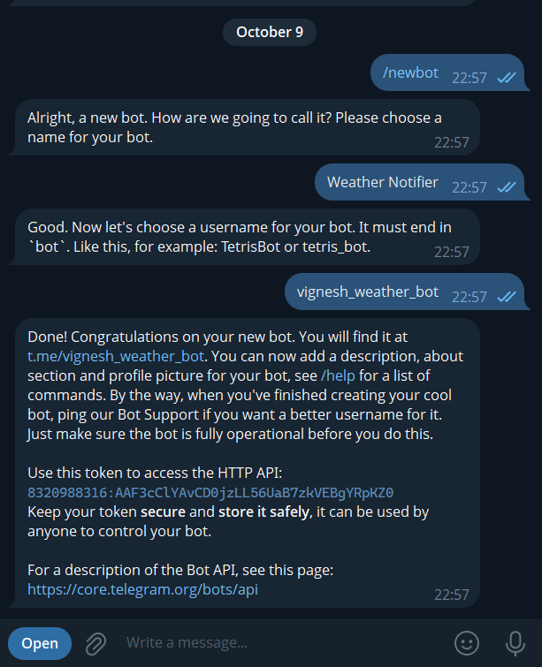
- Now go to https://api.telegram.org/bot<BOT_TOKEN>/getUpdates and instead of bot token enter your token and get the id from it

Step 2: Get Coordinates for Weather Data
- You can pick any location using Google Maps or GPS coordinates.
Example:
Latitude: 17.3850
Longitude: 78.4867 (Hyderabad)

Step 3: Use Open-Meteo API
Base URL:
https://api.open-meteo.com/v1/forecast?latitude=17.3850&longitude=78.4867&current_weather=true

This returns a JSON response like:
[
{
"latitude": 17.375,
"longitude": 78.5,
"generationtime_ms": 0.061511993408203125,
"utc_offset_seconds": 0,
"timezone": "GMT",
"timezone_abbreviation": "GMT",
"elevation": 505,
"current_weather_units": {
"time": "iso8601",
"interval": "seconds",
"temperature": "°C",
"windspeed": "km/h",
"winddirection": "°",
"is_day": "",
"weathercode": "wmo code"
},
"current_weather": {
"time": "2025-10-09T17:45",
"interval": 900,
"temperature": 25,
"windspeed": 1.1,
"winddirection": 198,
"is_day": 0,
"weathercode": 3
}]

Step 4: Build the Workflow in n8n

Trigger Node
- Type: Schedule
- Configuration: Every 6 hours

HTTP Request Node
- URL: Open-Meteo API endpoint(https://api.open-meteo.com/v1/forecast?latitude=17.3850&longitude=78.4867&current_weather=true)
- Method: GET
- Output: Weather data JSON

Telegram Node
- Action: Send Message
- Chat ID:6047474511
- Message: 🌤️ Daily Weather Update (Hyderabad) 📅 Time: {{ $json.current_weather.time }} 🌡️ Temperature: {{$json["current_weather"]["temperature"]}}°C 💨 Wind: {{$json["current_weather"]["windspeed"]}} km/h 🧭 Direction: {{$json["current_weather"]["winddirection"]}}°
- Bot Token: Use the one from @BotFather (use it to create new telegram credential to connect with)(8320988316:AAF3cClYAvCD0jzLL56UaB7zkVEBgYRpKZ0)

Workflow Flowchart

Visual Flow
We’ll include screenshots of each n8n node like this:
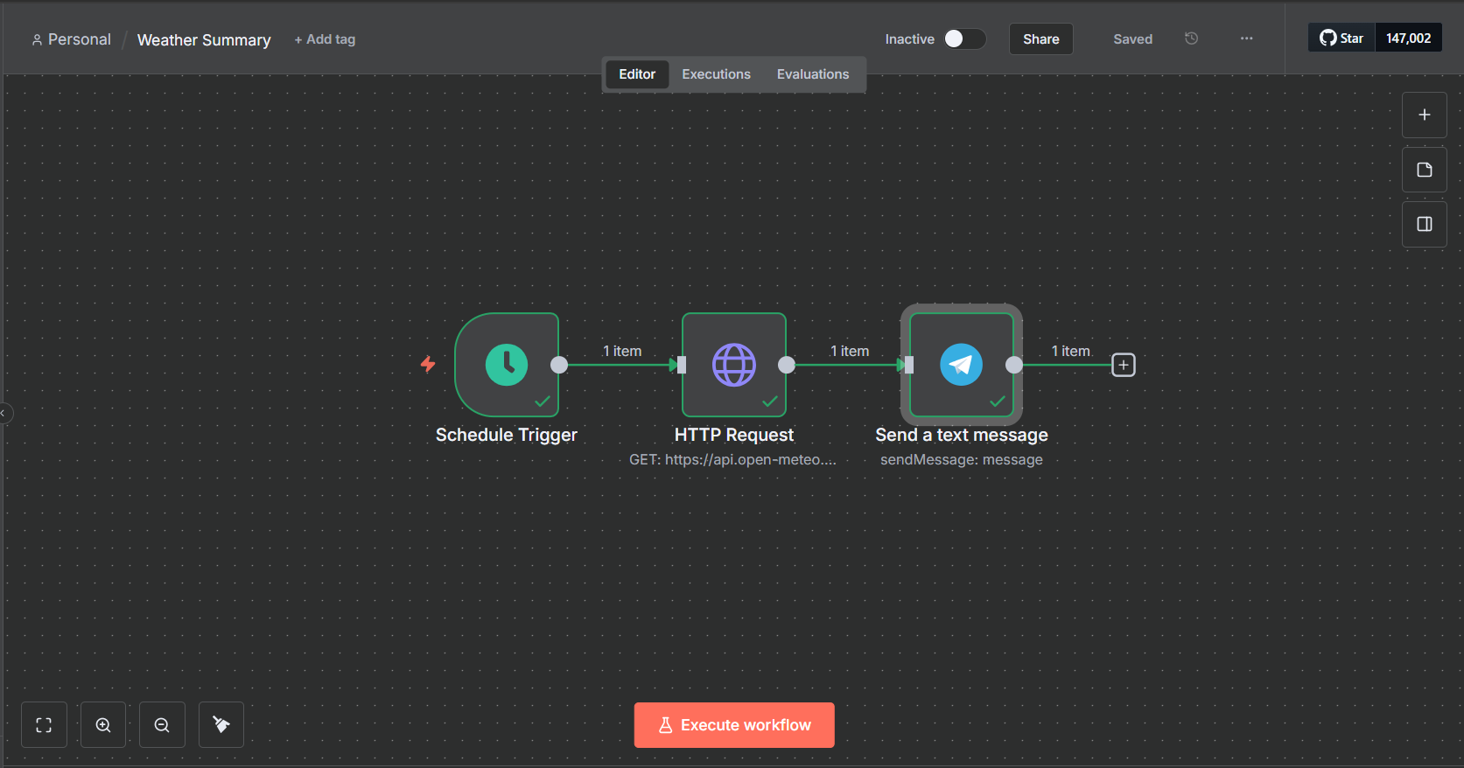
Automation Setup
To make it automatic every 6 hours:
- Open your Trigger Node in n8n
- Choose:
  - Mode: Every hours
  - Every: 6
- Activate the workflow (toggle “Active” in top right)
- The bot will now send weather updates every 6 hours automatically.
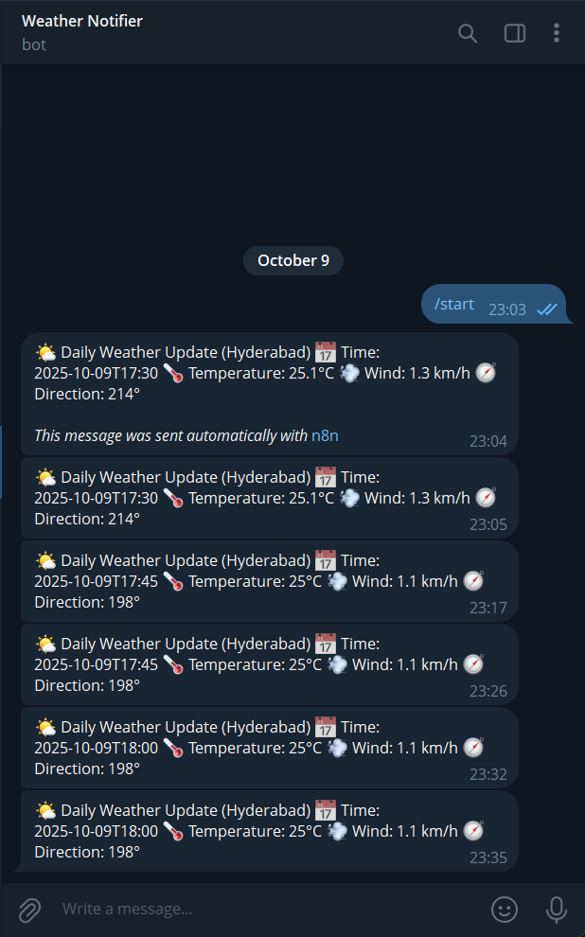

Conclusion
This project demonstrates how simple yet powerful no-code automation tools like n8n can integrate APIs and messaging platforms.
With minimal coding, we created an automated weather alert system that delivers real-time updates to users a perfect blend of practical use and technical creativity.

